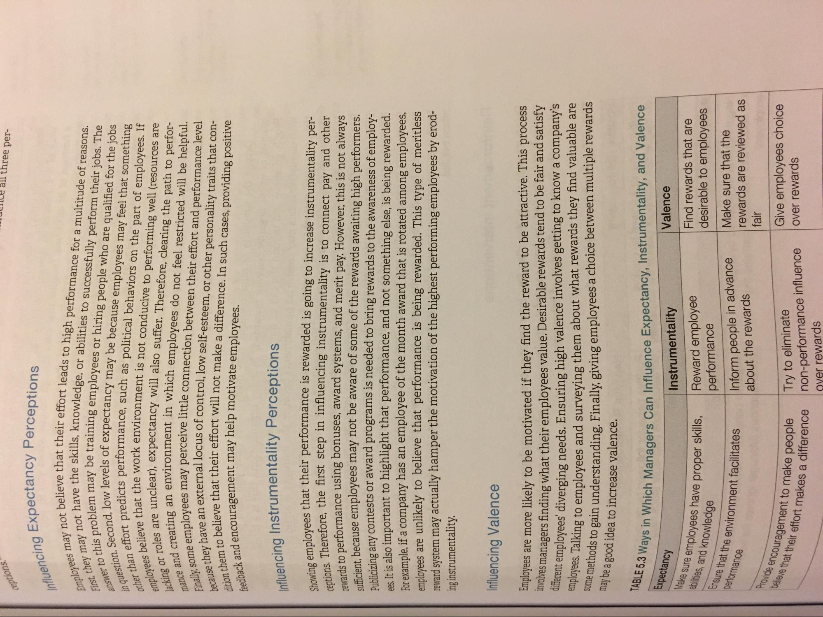
ceptions.
Ile all three per
Influencing Expe
na Expectancy Perceptions
Employees may not believe th First, they may not have the
swer to this problem may h in question. Second, low leve other than effort predicts per employees believe that the
lacking or roles
mance and creating an envir Finally, some employees m because they have an externali dition them to believe that th feedback and encoura
ve that their effort leads to high performance for a multitude of reasons.
the skills, knowledge, or abilities to successfully perform their jobs. The may be training employees or hiring people who are qualified for the jobs car levels of expectancy may be because employees may feel that something Hists performance, such as political behaviors on the part of employees. If at the work environment is not conducive to performing well (resources are
clear), expectancy will also suffer. Therefore, clearing the path to perforan environment in which employees do not feel restricted will be helpful. Jees may perceive little connection between their effort and performance level
external locus of control, low self-esteem, or other personality traits that conthat their effort will not make a difference. In such cases, providing positive
and encouragement may help motivate employees.
influencing Instrumentality Perceptions
Showing employees that their de ceptions. Therefore, the firs
reward
vees that their performance is rewarded is going to increase instrumentality perrefore, the first step in influencing instrumentality is to connect pay and other herformance using bonuses, award systems, and merit pay. However, this is not always
herause employees may not be aware of some of the rewards awaiting high performers. Hiving any contests or award programs is needed to bring rewards to the awareness of employ
It is also important to highlight that performance, and not something else, is being rewarded. For example, if a company has an employee of the month award that is rotated among employees, employees are unlikely to believe that performance is being rewarded. This type of meritless reward system may actually hamper the motivation of the highest performing employees by eroding instrumentality.
Influencing Valence
involve
Employees are more likely to be motivated if they find the reward to be attractive. This process oves managers finding what their employees value. Desirable rewards tend to be fair and satisfy cient employees' diverging needs. Ensuring high valence involves getting to know a company's yees, Talking to employees and surveying them about what rewards they find valuable are
ods to gain understanding. Finally, giving employees a choice between multiple rewards
some methods to gain unders
may be a good idea to increase valence.
ays in which Managers Can Influence Expectancy, Instrumentality, and Valence
Un Managers Can Influence
TABLE 5.3 Ways in which
Expectancy
Valence
Make sure emp
ure employees have proper skills,
Instrumentality Reward employee performance Inform people in advance about the rewards
Find rewards that are desirable to employees
abilities, and knowledge
performance
Ensure that the environ
e that the environment facilitates
Make sure that the rewards are reviewed as fair Give employees choice over rewards
Provide encouragement to
believe that their
ent to make people
a difference
Try to eliminate non-performance influence over rewards
e that their effort makes a dit

